Assignments-1

1.Write a Verilog code for 2X4 decoder.

Program :-

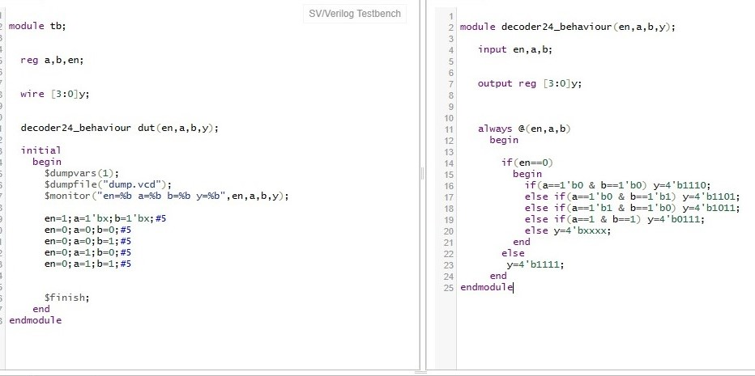

Output :-



2. Write a Verilog code for Full subtractor.

Program :-

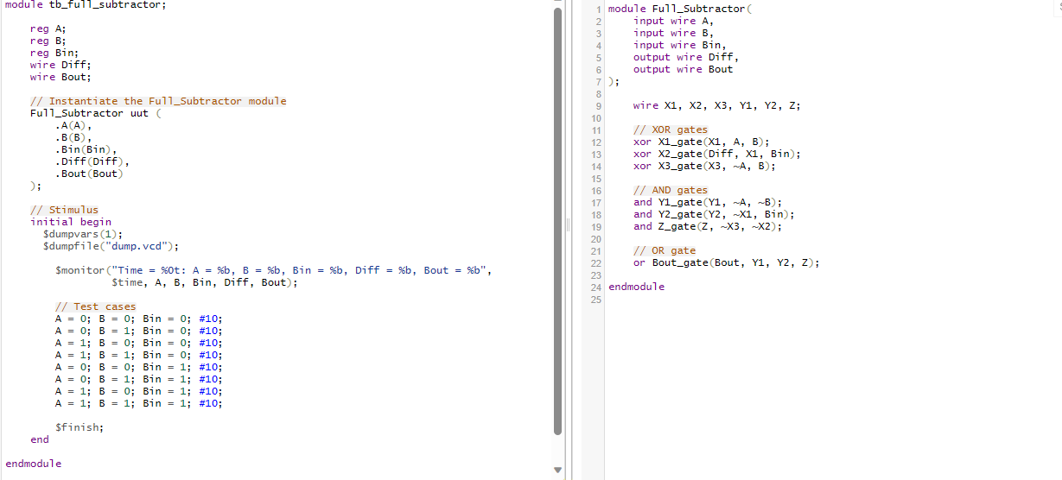

Output :-

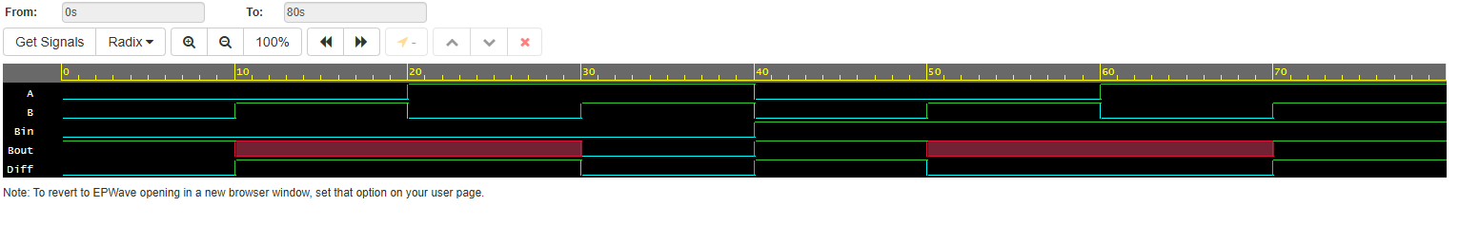

3. Write a Verilog code for 2-bit comparator.

Program :-

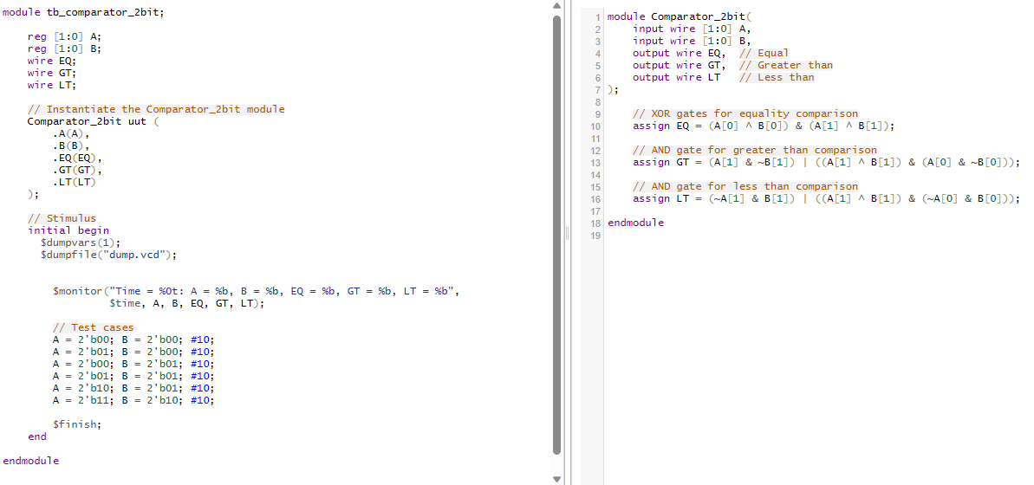

Output :-

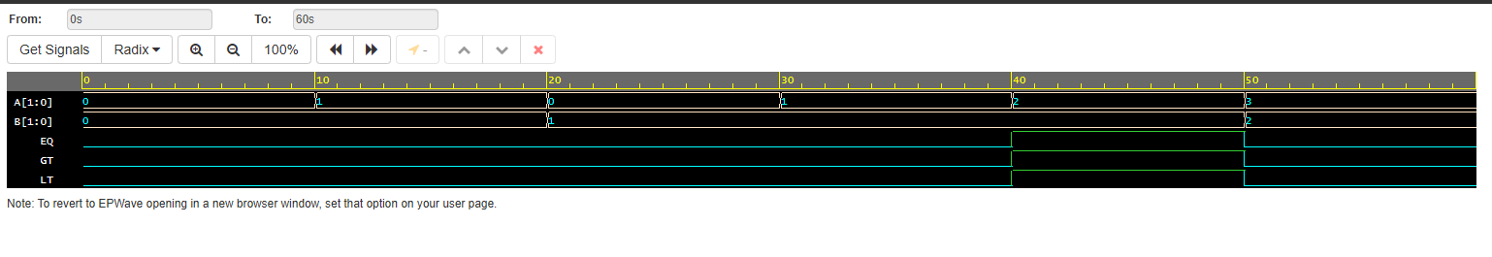

4. Write a Verilog code for 3 bit binary to gray convertor.

Program :-

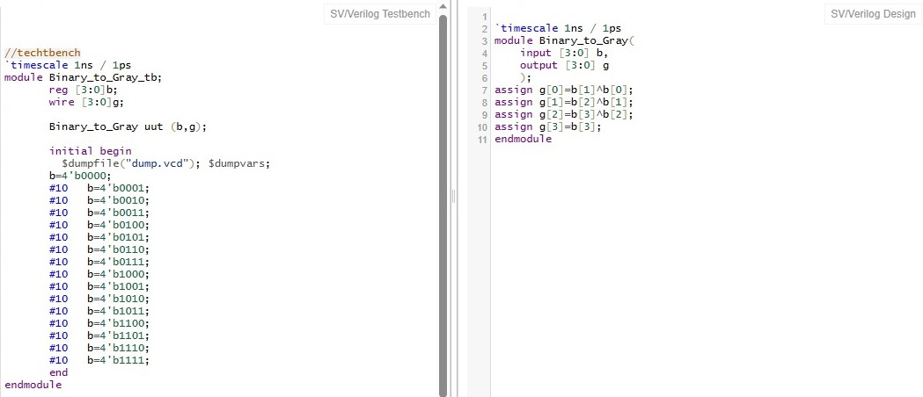

Output :-



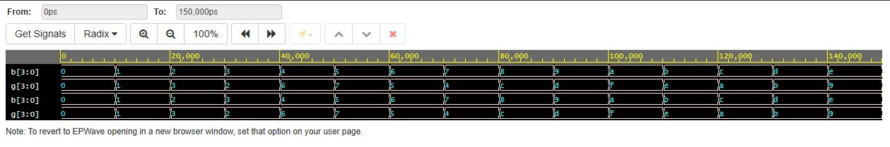

5. Write a Verilog code for BCD to excess 3 convertors.

Program :-

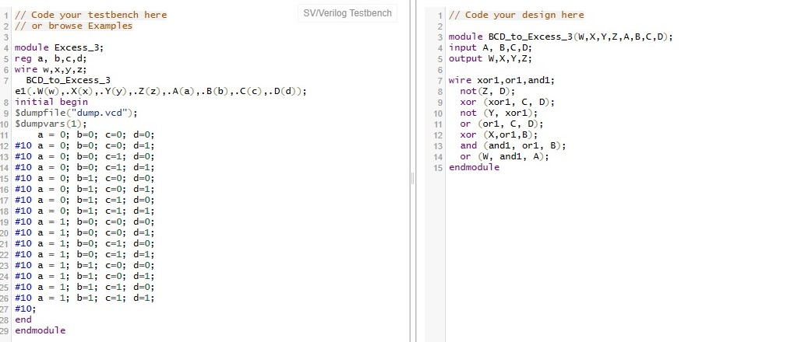

Output :-

s